Order Of Lenten Service

Children’s Hymn: “All Glory, Laud and Honor”

Reading: Matthew 21:1-11

Congregation Hymn: TLH 166

Reading: Lent VII

The History of the Passion of our Lord

Sermon Hymn: TLH 178

Sermon Text: Song Of Solomon 6:3

Eternal Election

Prayer

Holy Communion

The Lord's Prayer

The Blessing

Closing Hymn: TLH 179

* * * * * * * * * * * * *

Bible Study: Lambs: A Lamb
Sheep: Proverbs 14:6-10

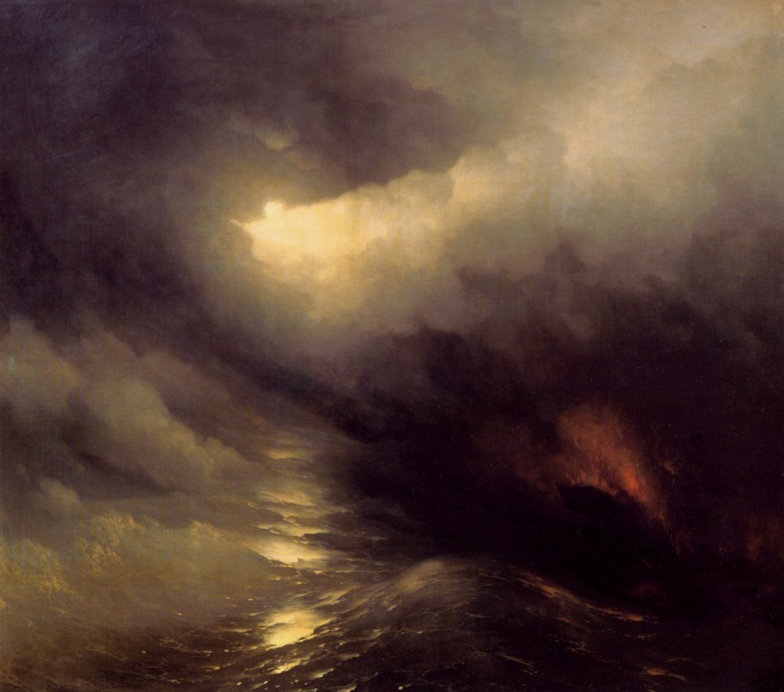

Let There Be Light

Water
Of
Life
9 April 2017

W A T E R O F L I F E

Independent Christian Church—Conservative Lutheran Doctrine

Worship Service: 9:30 a.m. Bible Study: 10:45 a.m.

Larry Cooper, Pastor E-Mail address:
111 N. Ridge Road lcooper@wateroflife.cc
Coon Valley, WI 54623 Web Site:
Phone: (608) 452-2105 www.wateroflife.cc

* * * * * * * * * * * * * * * * * * * * * * * * * * *

Sermon Text: Song Of Solomon 6:3

Eternal Election

* * * * * * * * * * * * * * * * * * * * * * * * * * *

Song of Solomon 6:3 I am my beloved's, and my beloved is mine: he feedeth among the lilies.

The first marriage in history took place in the Garden of Eden. The Holy Spirit has recorded the event for us in Genesis 2. Selected verses:

7 And the LORD God formed man of the dust of the ground, and breathed into his nostrils the breath of life; and man became a living soul. 8 And the LORD God planted a garden eastward in Eden; and there he put the man whom he had formed.
18 And the LORD God said, It is not good that the man should be alone; I will make him an help meet for him.

21 And the LORD God caused a deep sleep to fall upon Adam, and he slept: and he took one of his ribs, and closed up the flesh instead thereof;
22 And the rib, which the LORD God had taken from man, made he a woman, and brought her unto the man.
23 And Adam said, This is now bone of my bones, and flesh of my flesh: she shall be called Woman, because she was taken out of Man.
24 Therefore shall a man leave his father and his mother, and shall cleave unto his wife: and they shall be one flesh.



The last marriage in history will also take place in a Garden. Only this marriage speaks better things than did the marriage in Eden’s Garden. Song Of Solomon 6:2-3. 2 My beloved is gone down into his garden, to the beds of spices, to feed in the gardens, and to gather lilies.
3 I am my beloved's, and my beloved is mine: he feedeth among the lilies.

